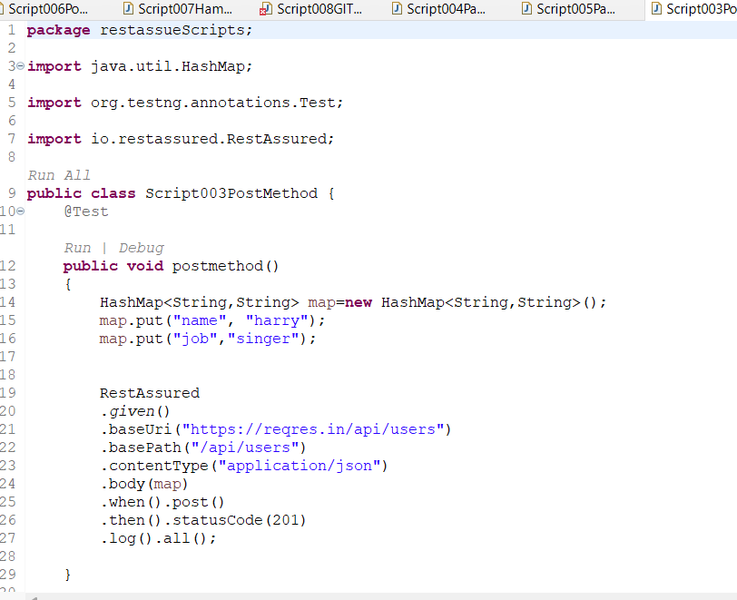

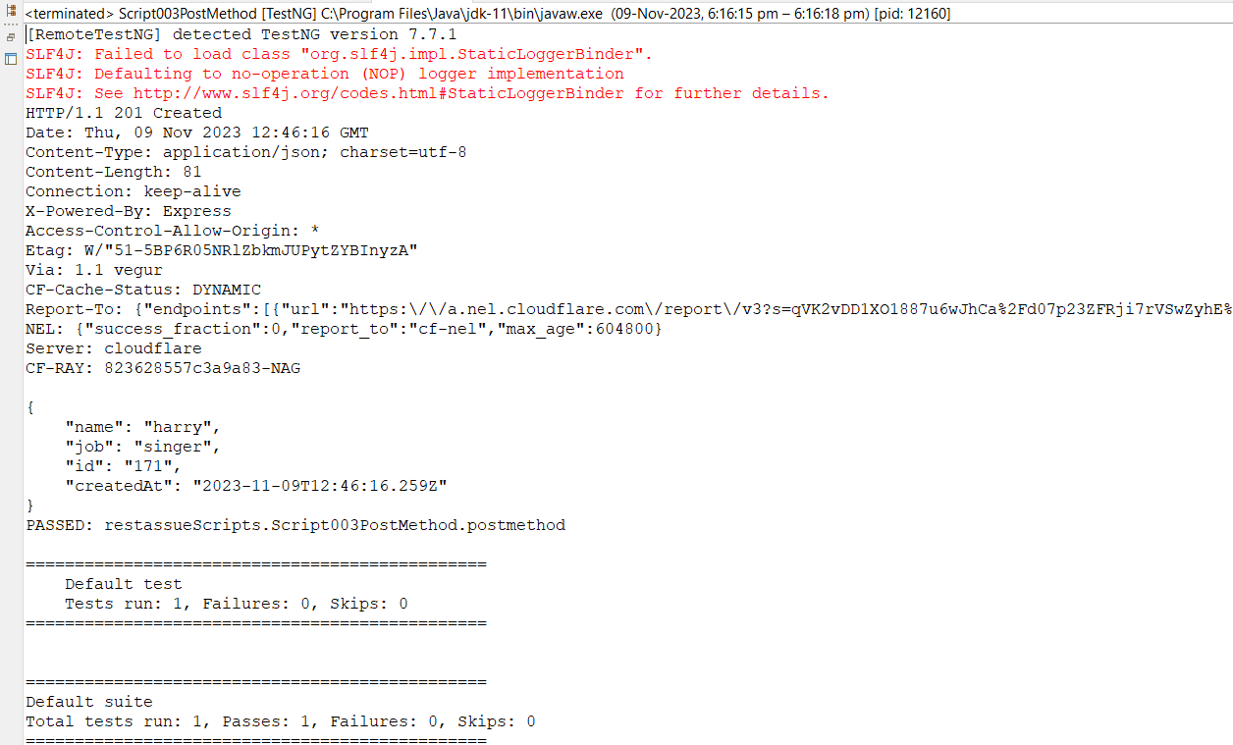

**Source code-**

**package** restassueScripts;

**import** java.util.HashMap;

**import** org.testng.annotations.Test;

**import** io.restassured.RestAssured;

**public** **class** Script003PostMethod {

@Test

**public** **void** postmethod()

{

HashMap<String,String> map=**new** HashMap<String,String>();

map.put("name", "harry");

map.put("job","singer");

RestAssured

.*given*()

.baseUri("https://reqres.in/api/users")

.basePath("/api/users")

.contentType("application/json")

.body(map)

.when().post()

.then().statusCode(201)

.log().all();

}

}